Marathwada Mitra Mandal’s

College of Engineering, Pune

Karve Nagar, Pune-411 052



**Department of Computer Engineering**



410246: Laboratory Practice III

Design and Analysis of Algorithm

**BE COMPUTER**

Prepared by:

**Dr. Swati Shekapure**

**Dr. Arati Agarkar**

***410246: Laboratory Practice III***

Design and Analysis of Algorithm

1. **Course Outcome**

|  |  |
| --- | --- |
| **Course Outcome** | **Statement** |
| *At the end of the course, student will be able to* |
| 410246.1 | Analyze performance of an algorithm. |
| 410246.2 | Implement an algorithm that follows one of the following algorithm design strategies: divide and conquer, greedy, dynamic programming, backtracking, branch and bound. |

1. **CO-PO Mapping (Levels :1-Low , 2-Medium, 3-High)**

|  |  |  |  |  |  |  |  |  |  |  |  |  |
| --- | --- | --- | --- | --- | --- | --- | --- | --- | --- | --- | --- | --- |
| **Course Outcome** | **Program outcomes** | | | | | | | | | | | |
| **1** | **2** | **3** | **4** | **5** | **6** | **7** | **8** | **9** | **10** | **11** | **12** |
| 410246.1 | 3 | 2 | 2 | - | 1 | - | - | 1 | 2 | - | 2 | 2 |
| 410246.2 | 3 | 2 | 3 | - | 1 | - | - | 1 | 2 | - | - | 2 |

**CO-PSO mapping**

|  |  |  |  |
| --- | --- | --- | --- |
| **Course Outcome** | **Program Specific Outcomes** | | |
| **1** | **2** |  |
| 410246.1 | 2 | 2 |  |
| 410246.2 | 2 | 2 |  |

*Semester I Academic Year 2022-23*

**INDEX**

|  |  |  |  |  |  |
| --- | --- | --- | --- | --- | --- |
| **Sr.**  **No.** | **Group** | **Title of Assignment** | **CO** | **PO** | **PSO** |
| 1 | A | Write a program to calculate Fibonacci numbers and find its step count. | 1 | High: 1  Medium:2,3,9,11,12  Low:5,8 | Medium:1,2 |
| 2 | A | Write a program to implement Huffman Encoding using a greedy strategy. | 2 | High: 1,3  Medium:2,9,12  Low:5,8 | Medium:1,2 |
| 3 | A | Write a program to solve a fractional Knapsack problem using a greedy method. | 2 | High: 1,3  Medium:2,9,12  Low:5,8 | Medium:1,2 |
| 4 | A | Write a program to solve a 0-1 Knapsack problem using dynamic programming or branch and bound strategy. | 2 | High: 1,3  Medium:2,9,12  Low:5,8 | Medium:1,2 |
| 5 | A | Design n-Queens matrix having first Queen placed. Use backtracking to place remaining Queens to generate the final 8-queen’s matrix. | 2 | High: 1,3  Medium:2,9,12  Low:5,8 | Medium:1,2 |
| 6 | A | Write a program for analysis of quick sort by using deterministic and randomized variants. | 2 | High: 1,3  Medium:2,9,12  Low:5,8 | Medium:1,2 |
| 7A | A | **Mini Project:** Write a program to implement matrix multiplication. Also implement multithreaded matrix multiplication with either one thread per row or one thread per cell. Analyze and compare their performance. | 2 | High: 1,3  Medium:2,9,12  Low:5,8 | Medium:1,2 |
| 7B | A | **Mini Project:**Implement merge sort and multithreaded merge sort. Compare time required by both the algorithms. Also analyze the performance of each algorithm for the best case and the worst case | 2 | High: 1,3  Medium:2,9,12  Low:5,8 | Medium:1,2 |
| 7C | A | **Mini Project:**Implement the Naive string matching algorithm and Rabin-Karp algorithm for string matching. Observe difference in working of both the algorithms for the same input. | 2 | High: 1,3  Medium:2,9,12  Low:5,8 | Medium:1,2 |
| 7D | A | **Mini Project -** Different exact and approximation algorithms for Travelling-Sales-Person Problem | 2 | High: 1,3  Medium:2,9,12  Low:5,8 | Medium:1,2 |
| 8 | CBS | Design 8-Queens matrix having first Queen placed. Use Branch and Bound to place remaining Queens to generate the final 8-queen’s matrix. | 2 | High: 1,3  Medium:2,9,12  Low:5,8 | Medium:1,2 |

**Assignment No. 1**

**TITLE:** Write a program to calculate Fibonacci numbers and find its step count

**OBJECTIVE :**Learn how to analyze the performance of an algorithm

**OUTCOME:** Analyze performance of an algorithm.

**THEORY:**

Fibonacci Series generates subsequent numbers by adding two previous numbers. The Fibonacci series starts from two numbers − F0 & F1. The initial values of F0 & F1 can be taken 0, 1 or 1, 1 respectively.

Fibonacci series satisfies the following conditions −

Fn = Fn-1 + Fn-2

So a Fibonacci series can look like this −

F8 = 0 1 1 2 3 5 8 13

or, this −

F8 = 1 1 2 3 5 8 13 21

If we denote the number at position n as Fn, we can formally define the Fibonacci Sequence as:

Fn = 0 for n = 0

Fn = 1 for n = 1

Fn = Fn-1 + Fn-2 for n > 1

Therefore, the start of the sequence is:

0, 1, 1, 2, 3, 5, 8, 13, …

**Recursive Algorithm**

Our first solution will implement recursion. This is probably the most intuitive approach, since the Fibonacci Sequence is, by definition, a recursive relation.

**Method**

Let’s start by defining F(n) as the function that returns the value of Fn.

To evaluate F(n) for n > 1, we can reduce our problem into two smaller problems of the same kind: F(n-1) and F(n-2).

We can further reduce F(n-1) and F(n-2) to F((n-1)-1) and F((n-1)-2); and F((n-2)-1) and F((n-2)-2), respectively.

If we repeat this reduction, we’ll eventually reach our known base cases and, thereby, obtain a solution to F(n).

Employing this logic, our algorithm for F(n) will have two steps:

Check if n ≤ 1. If so, return n.

Check if n > 1. If so, call our function F with inputs n-1 and n-2, and return the sum of the two results.

Here’s a visual representation of this algorithm:

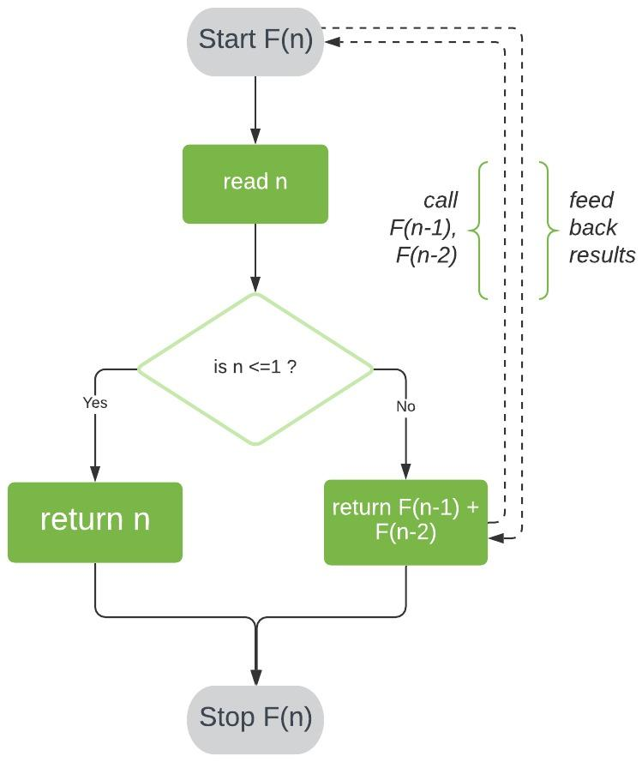

**Pseudocode**

Now that we understand how this algorithm works, let’s implement some pseudocode:

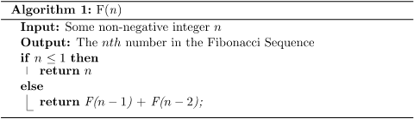

**Analysis of Time Complexity**

We can analyze the time complexity of F(n) by counting the number of times its most expensive operation will execute for n number of inputs. For this algorithm, the operation contributing the greatest runtime cost is addition.

**Finding an Equation for Time Complexity**

F0 = 0

Fn=1

Fn=F(n-1)+ F(n-2)

**Fig : Recursive calls during computation of Fibonacci number**

**Analyzing Our Solution**

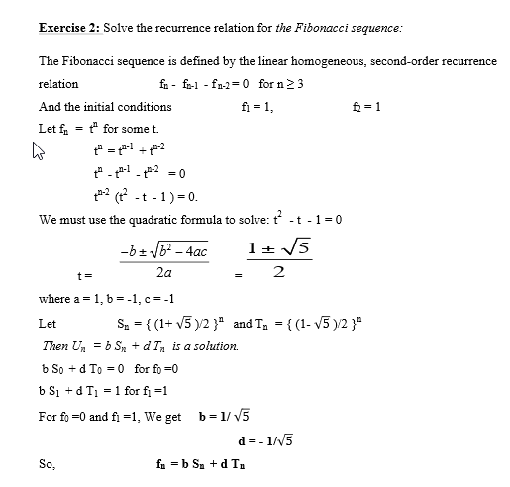

**Iterative Algorithm**

Let’s move on to a much more efficient way of calculating the Fibonacci Sequence.

For this algorithm, we’ll start at our known base cases and then evaluate each succeeding value until we finally reach the nth number. We’ll store our sequence in an array F[].

**Method**

First, we’ll store 0 and 1 in F[0] and F[1], respectively.

Next, we’ll iterate through array positions 2 to n-1. At each position i, we store the sum of the two preceding array values in F[i].

Finally, we return the value of F[n-1], giving us the number at position n in the sequence.

Here’s a visual representation of this process:

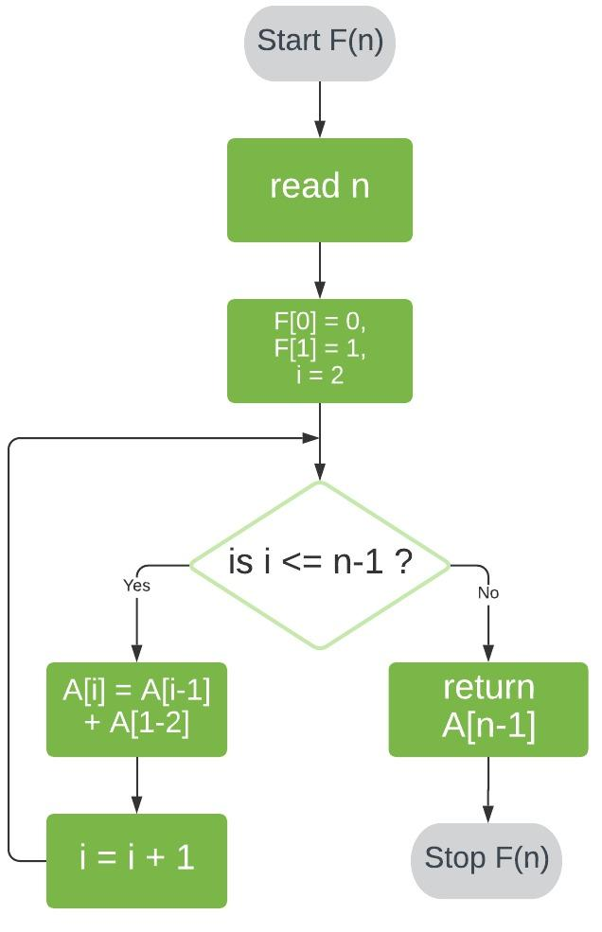

**Pseudocode**

Let’s take a look at the pseudocode for this approach:

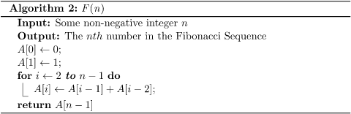

**Time Complexity**

Analyzing the time complexity for our iterative algorithm is a lot more straightforward than its recursive counterpart.

In this case, our most costly operation is assignment. Firstly, our assignments of F[0] and F[1] cost O(1) each. Secondly, our loop performs one assignment per iteration and executes (n-1)-2 times, costing a total of O(n-3) = O(n).

Therefore, our iterative algorithm has a time complexity of O(n) + O(1) + O(1) = O(n).

This is a marked improvement from our recursive algorithm!

**CONCLUSION:** Hence, We have Successfully Implemented Fibonacci Algorithm recursively and Iteratively.

**Assignment No. 2**

**TITLE:** Write a program to implement Huffman Encoding using a greedy strategy.

**OBJECTIVE:** Learn how to implement algorithms that follow algorithm design strategies namely divide and conquer, greedy, dynamic programming, backtracking, branch and bound.

**OUTCOME:** Implement an algorithm that follows one of the following algorithm design strategies: divide and conquer, greedy, dynamic programming, backtracking, branch and bound.

## THEORY:

Huffman coding is a lossless data compression algorithm. The idea is to assign variable-length codes to input characters; lengths of the assigned codes are based on the frequencies of corresponding characters. The most frequent character gets the smallest code and the least frequent character gets the largest code.

The variable-length codes assigned to input characters are Prefix Codes, meaning the codes (bit sequences) are assigned in such a way that the code assigned to one character is not the prefix of code assigned to any other character. This is how Huffman Coding makes sure that there is no ambiguity when decoding the generated bitstream.

Let us understand prefix codes with a counter example. Let there be four characters a, b, c and d, and their corresponding variable length codes be 00, 01, 0 and 1. This coding leads to ambiguity because code assigned to c is the prefix of codes assigned to a and b. If the compressed bit stream is 0001, the de-compressed output may be “cccd” or “ccb” or “acd” or “ab”.

There are mainly two major parts in Huffman Coding

1. Build a Huffman Tree from input characters.
2. Traverse the Huffman Tree and assign codes to characters.

Steps to build Huffman Tree

Input is an array of unique characters along with their frequency of occurrences and output is Huffman Tree.

1. create a priority queue Q consisting of each unique character.
2. sort then in ascending order of their frequencies.

for all the unique characters:

create a newNode

extract minimum value from Q and assign it to leftChild of newNode

extract minimum value from Q and assign it to rightChild of newNode

calculate the sum of these two minimum values and assign it to the value of newNode

insert this newNode into the tree

return rootNode

Example:

character Frequency

a 5

b 9

c 12

d 13

e 16

f 45

Step 1. Build a min heap that contains 6 nodes where each node represents the root of a tree with a single node.

Step 2 Extract two minimum frequency nodes from the min heap. Add a new internal node with frequency 5 + 9 = 14.

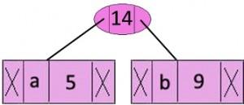

Now min heap contains 5 nodes where 4 nodes are roots of trees with single element each, and one heap node is root of tree with 3 elements

character Frequency

c 12

d 13

Internal Node 14

e 16

f 45

**Step 3:** Extract two minimum frequency nodes from heap. Add a new internal node with frequency 12 + 13 = 25

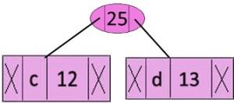

Now min heap contains 4 nodes where 2 nodes are roots of trees with single element each, and two heap nodes are root of tree with more than one nodes

**Character Frequency**

Internal Node 14

e 16

Internal Node 25

f 45

**Step 4:** Extract two minimum frequency nodes. Add a new internal node with frequency 14 + 16 = 30

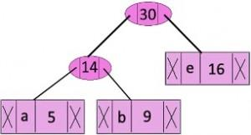

Now the min heap contains 3 nodes.

**Character Frequency**

Internal Node 25

Internal Node 30

f 45

**Step 5:** Extract two minimum frequency nodes. Add a new internal node with frequency 25 + 30 = 55

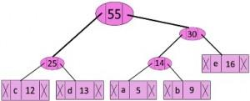

Now the min heap contains 2 nodes.

**Character Frequency**

f 45

Internal Node 55

**Step 6:** Extract two minimum frequency nodes. Add a new internal node with frequency 45 + 55 = 100

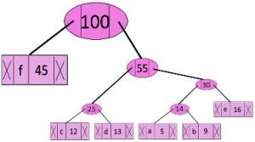

Now the min heap contains only one node.

**Character Frequency**

Internal Node 100

Since the heap contains only one node, the algorithm stops here.

***Steps to print codes from Huffman Tree:***

Traverse the tree formed starting from the root. Maintain an auxiliary array. While moving to the left child, write 0 to the array. While moving to the right child, write 1 to the array. Print the array when a leaf node is encountered.

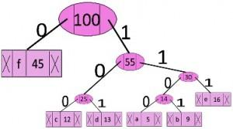

The codes are as follows:

**Character code-word**

f 0

c 100

d 101

a 1100

b 1101

e 111

## Huffman Coding Complexity

## The time complexity for encoding each unique character based on its frequency is O(nlog n).

## Extracting minimum frequency from the priority queue takes place 2*(n-1) times and its complexity is O(log n). Thus the overall complexity is O(nlog n).

**CONCLUSION:** Hence , We have Successfully implemented Huffman Coding

A**ssignment No. 3**

**TITLE:** Write a program to solve a fractional Knapsack problem using a greedy method

**OBJECTIVE:** Learn how to implement algorithms that follow algorithm design strategies namely divide and conquer, greedy, dynamic programming, backtracking, branch and bound.

**OUTCOME:** Implement an algorithm that follows one of the following algorithm design strategies: divide and conquer, greedy, dynamic programming, backtracking, branch and bound.

**THEORY:**

## Knapsack Problem

Given a set of items, each with a weight and a value, determine a subset of items to include in a collection so that the total weight is less than or equal to a given limit and the total value is as large as possible.

The knapsack problem is a combinatorial optimization problem. It appears as a subproblem in many, more complex mathematical models of real-world problems. One general approach to difficult problems is to identify the most restrictive constraint, ignore the others, solve a knapsack problem, and somehow adjust the solution to satisfy the ignored constraints.

### Applications

In many cases of resource allocation along with some constraint, the problem can be derived in a similar way to the Knapsack problem. Following is a set of examples.

* Finding the least wasteful way to cut raw materials
* portfolio optimization
* Cutting stock problems

### Problem Scenario

A thief is robbing a store and can carry a maximal weight of *W* into his knapsack. There are n items available in the store and the weight of *ith* item is *wi* and its profit is *pi*. What items should the thief take?

In this context, the items should be selected in such a way that the thief will carry those items for which he will gain maximum profit. Hence, the objective of the thief is to maximize the profit.

Based on the nature of the items, Knapsack problems are categorized as

* Fractional Knapsack
* Knapsack

## Fractional Knapsack

In this case, items can be broken into smaller pieces, hence the thief can select fractions of items.

According to the problem statement,

* There are n items in the store
* Weight of ith item *wi* >0
* Profit for ith item *pi* >0 and
* Capacity of the Knapsack is W

In this version of Knapsack problem, items can be broken into smaller pieces. So, the thief may take only a fraction *xi* of ith item.

0⩽ *xi* ⩽1

The ith item contributes the weight *xi*.*wi* to the total weight in the knapsack and profit *xi*.*pi* to the total profit.

Hence, the objective of this algorithm is to

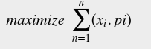

subject to constraint,

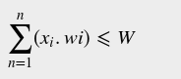

It is clear that an optimal solution must fill the knapsack exactly, otherwise we could add a fraction of one of the remaining items and increase the overall profit.

Thus, an optimal solution can be obtained by

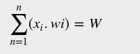

In this context, first we need to sort those items according to the value of



Here, *x* is an array to store the fraction of items.

**Algorithm: Greedy-Fractional-Knapsack (w[1..n], p[1..n], W)**

for i = 1 to n

do x[i] = 0

weight = 0

for i = 1 to n

if weight + w[i] ≤ W then

x[i] = 1

weight = weight + w[i]

else

x[i] = (W - weight) / w[i]

weight = W

break

return x

### Analysis

If the provided items are already sorted into a decreasing order of pi/wi , then the while loop takes a time in *O(n)*;

Example

Let us consider that the capacity of the knapsack *W* = 60 and the list of provided items are shown in the following table −

|  |  |  |  |  |
| --- | --- | --- | --- | --- |
| **Item** | **A** | **B** | **C** | **D** |
| Profit | 280 | 100 | 120 | 120 |
| Weight | 40 | 10 | 20 | 24 |
| Ratio  (*pi /wi*) | 7 | 10 | 6 | 5 |

|  |  |  |  |  |
| --- | --- | --- | --- | --- |
|  |  |  |  |  |

As the provided items are not sorted based on pi/wi .After sorting, the items are as shown in the following table.

|  |  |  |  |  |
| --- | --- | --- | --- | --- |
| **Item** | **B** | **A** | **C** | **D** |
| Profit | 100 | 280 | 120 | 120 |
| Weight | 10 | 40 | 20 | 24 |
| Ratio  (*pi/wi*) | 10 | 7 | 6 | 5 |

### Solution

After sorting all the items according to *pi/wi*. First all of *B* is chosen as the weight of *B* is less than the capacity of the knapsack. Next, item *A* is chosen, as the available capacity of the knapsack is greater than the weight of *A*. Now, *C* is chosen as the next item.

Hence, a fraction of *C* (i.e. (60 − 50)/20) is chosen.

Now, the capacity of the Knapsack is equal to the selected items. Hence, no more item can be selected.

The total weight of the selected items is 10 + 40 + 20 * (10/20) = 60

And the total profit is 100 + 280 + 120 * (10/20) = 380 + 60 = 440

This is the optimal solution. We cannot gain more profit selecting any different combination of items.

**Conclusion:**

**Hence , we can conclude that we have successfully implemented fractional knapsack using greedy strategy.**

**FAQs:**

1. Solve Job sequencing with deadline using greedy algorithm

|  |  |  |  |  |  |
| --- | --- | --- | --- | --- | --- |
| Job | J1 | J2 | J3 | J4 | J5 |
| Deadline | 2 | 1 | 3 | 2 | 1 |
| Profit | 60 | 100 | 20 | 40 | 20 |

1. What are the components of a greedy algorithm?
2. State the best, average and worst case complexities of binary search for successful and unsuccessful search.
3. State the principle of optimality. Find two problems for which the principle does not hold.

**Assignment No. 4**

**TITLE:** Write a program to solve a 0-1 Knapsack problem using dynamic programming or branch and bound strategy

**OBJECTIVE:** Learn how to implement algorithms that follow algorithm design strategies namely divide and conquer, greedy, dynamic programming, backtracking, branch and bound.

**OUTCOME:** Implement an algorithm that follows one of the following algorithm design strategies: divide and conquer, greedy, dynamic programming, backtracking, branch and bound.

**THEORY:**

**Dynamic Programming:**

Dynamic Programming is mainly an optimization over plain recursion. Wherever we see a recursive solution that has repeated calls for the same inputs, we can optimize it using Dynamic Programming. The idea is to simply store the results of subproblems, so that we do not have to re-compute them when needed later. This simple optimization reduces time complexities from exponential to polynomial.

Dynamic programming is a step by step solution. At each step, the decision is taken to get the optimal solution.

**Knapsack Problem:**

Given weights and values of n items, put these items in a knapsack of capacity W to get the maximum total value in the knapsack. In other words, given two integer arrays val[0..n-1] and wt[0..n-1] which represent values and weights associated with n items respectively. Also given an integer W which represents knapsack capacity, find out the maximum value subset of val[] such that sum of the weights of this subset is smaller than or equal to W. You cannot break an item, either pick the complete item or don’t pick it (0-1 property).

**Dynamic programming for 0/1 knapsack problem:**

## Knapsack Problem-

You are given the following-

* A knapsack (kind of shoulder bag) with limited weight capacity.
* Few items each having some weight and value.

**The problem states-**

Which items should be placed into the knapsack such that-

* The value or profit obtained by putting the items into the knapsack is maximum.
* And the weight limit of the knapsack does not exceed.

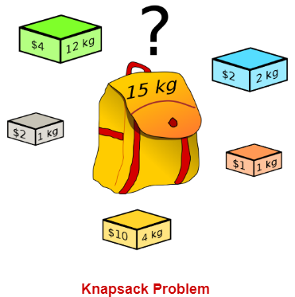

## Knapsack Problem Variants-

Knapsack problem has the following two variants-

1. Fractional Knapsack Problem
2. 0/1 Knapsack Problem

## 0/1 Knapsack Problem-

In 0/1 Knapsack Problem,

* As the name suggests, items are indivisible here.
* We can not take the fraction of any item.
* We have to either take an item completely or leave it completely.
* It is solved using a dynamic programming approach.

0/1 Knapsack Problem Using Dynamic Programming-

Consider-

* Knapsack weight capacity = w
* Number of items each having some weight and value = n

0/1 knapsack problem is solved using dynamic programming in the following steps-

### Step-01:

* Draw a table say ‘T’ with (n+1) number of rows and (w+1) number of columns.
* Fill all the boxes of 0th row and 0th column with zeros as shown-

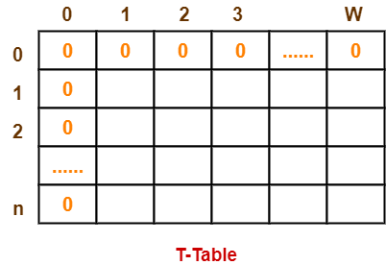

### Step-02:

Start filling the table row wise top to bottom from left to right.

Use the following formula-

**T (i , j) = max { T ( i-1 , j ) , valuei + T( i-1 , j – weighti ) }**

Here, T(i , j) = maximum value of the selected items if we can take items 1 to i and have weight restrictions of j.

* This step leads to completely filling the table.
* Then, value of the last box represents the maximum possible value that can be put into the knapsack.

### Step-03:

To identify the items that must be put into the knapsack to obtain that maximum profit,

* Consider the last column of the table.
* Start scanning the entries from bottom to top.
* On encountering an entry whose value is not same as the value stored in the entry immediately above it, mark the row label of that entry.
* After all the entries are scanned, the marked labels represent the items that must be put into the knapsack.

## Time Complexity-

* Each entry of the table requires constant time θ(1) for its computation.
* It takes θ(nw) time to fill (n+1)(w+1) table entries.
* It takes θ(n) time for tracing the solution since tracing process traces the n rows.
* Thus, overall θ(nw) time is taken to solve 0/1 knapsack problem using dynamic programming.

## Problem-

Find the optimal solution for the 0/1 knapsack problem making use of a dynamic programming approach. Consider-

n = 4

w = 5 kg

(w1, w2, w3, w4) = (2, 3, 4, 5)

(b1, b2, b3, b4) = (3, 4, 5, 6)

**OR**

A thief enters a house for robbing it. He can carry a maximal weight of 5 kg into his bag. There are 4 items in the house with the following weights and values. What items should the thief take if he either takes the item completely or leaves it completely?

|  |  |  |
| --- | --- | --- |
| **Item** | **Weight** | **Value** |
| 1 | 2 | 3 |
| 2 | 3 | 4 |
| 3 | 4 | 5 |
| 4 | 5 | 6 |

## Solution-

### Given-

* Knapsack capacity (w) = 5 kg
* Number of items (n) = 4

### Step-01:

* Draw a table say ‘T’ with (n+1) = 4 + 1 = 5 number of rows and (w+1) = 5 + 1 = 6 number of columns.
* Fill all the boxes of 0th row and 0th column with 0.

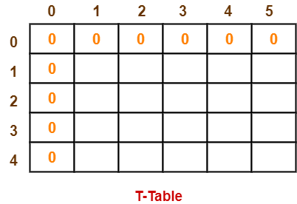

### Step-02:

Start filling the table row wise top to bottom from left to right using the formula-

**T (i , j) = max { T ( i-1 , j ) , valuei + T( i-1 , j – weighti ) }**

### Finding T(1,1)-

We have,

* i = 1
* j = 1
* (value)i = (value)1 = 3
* (weight)i = (weight)1 = 2

Substituting the values, we get-

T(1,1) = max { T(1-1 , 1) , 3 + T(1-1 , 1-2) }

T(1,1) = max { T(0,1) , 3 + T(0,-1) }

T(1,1) = T(0,1) { Ignore T(0,-1) }

T(1,1) = 0

### Finding T(1,2)-

We have,

* i = 1
* j = 2
* (value)i = (value)1 = 3
* (weight)i = (weight)1 = 2

Substituting the values, we get-

T(1,2) = max { T(1-1 , 2) , 3 + T(1-1 , 2-2) }

T(1,2) = max { T(0,2) , 3 + T(0,0) }

T(1,2) = max {0 , 3+0}

T(1,2) = 3

### Finding T(1,3)-

We have,

* i = 1
* j = 3
* (value)i = (value)1 = 3
* (weight)i = (weight)1 = 2

Substituting the values, we get-

T(1,3) = max { T(1-1 , 3) , 3 + T(1-1 , 3-2) }

T(1,3) = max { T(0,3) , 3 + T(0,1) }

T(1,3) = max {0 , 3+0}

T(1,3) = 3

### Finding T(1,4)-

We have,

* i = 1
* j = 4
* (value)i = (value)1 = 3
* (weight)i = (weight)1 = 2

Substituting the values, we get-

T(1,4) = max { T(1-1 , 4) , 3 + T(1-1 , 4-2) }

T(1,4) = max { T(0,4) , 3 + T(0,2) }

T(1,4) = max {0 , 3+0}

T(1,4) = 3

### Finding T(1,5)-

We have,

* i = 1
* j = 5
* (value)i = (value)1 = 3
* (weight)i = (weight)1 = 2

Substituting the values, we get-

T(1,5) = max { T(1-1 , 5) , 3 + T(1-1 , 5-2) }

T(1,5) = max { T(0,5) , 3 + T(0,3) }

T(1,5) = max {0 , 3+0}

T(1,5) = 3

### Finding T(2,1)-

We have,

* i = 2
* j = 1
* (value)i = (value)2 = 4
* (weight)i = (weight)2 = 3

Substituting the values, we get-

T(2,1) = max { T(2-1 , 1) , 4 + T(2-1 , 1-3) }

T(2,1) = max { T(1,1) , 4 + T(1,-2) }

T(2,1) = T(1,1) { Ignore T(1,-2) }

T(2,1) = 0

### Finding T(2,2)-

We have,

* i = 2
* j = 2
* (value)i = (value)2 = 4
* (weight)i = (weight)2 = 3

Substituting the values, we get-

T(2,2) = max { T(2-1 , 2) , 4 + T(2-1 , 2-3) }

T(2,2) = max { T(1,2) , 4 + T(1,-1) }

T(2,2) = T(1,2) { Ignore T(1,-1) }

T(2,2) = 3

### Finding T(2,3)-

We have,

* i = 2
* j = 3
* (value)i = (value)2 = 4
* (weight)i = (weight)2 = 3

Substituting the values, we get-

T(2,3) = max { T(2-1 , 3) , 4 + T(2-1 , 3-3) }

T(2,3) = max { T(1,3) , 4 + T(1,0) }

T(2,3) = max { 3 , 4+0 }

T(2,3) = 4

### Finding T(2,4)-

We have,

* i = 2
* j = 4
* (value)i = (value)2 = 4
* (weight)i = (weight)2 = 3

Substituting the values, we get-

T(2,4) = max { T(2-1 , 4) , 4 + T(2-1 , 4-3) }

T(2,4) = max { T(1,4) , 4 + T(1,1) }

T(2,4) = max { 3 , 4+0 }

T(2,4) = 4

### Finding T(2,5)-

We have,

* i = 2
* j = 5
* (value)i = (value)2 = 4
* (weight)i = (weight)2 = 3

Substituting the values, we get-

T(2,5) = max { T(2-1 , 5) , 4 + T(2-1 , 5-3) }

T(2,5) = max { T(1,5) , 4 + T(1,2) }

T(2,5) = max { 3 , 4+3 }

T(2,5) = 7

Similarly, compute all the entries.

After all the entries are computed and filled in the table, we get the following table-

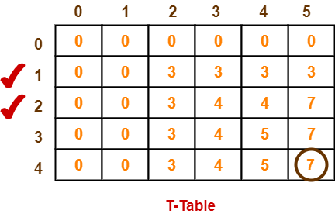

* The last entry represents the maximum possible value that can be put into the knapsack.
* So, maximum possible value that can be put into the knapsack = 7.

### Identifying Items To Be Put Into Knapsack-

Following Step-04,

* We mark the rows labeled “1” and “2”.
* Thus, items that must be put into the knapsack to obtain the maximum value 7 are- **Item-1 and Item-2**

**Algorithm**

Dynamic-0-1-knapsack (v, w, n, W)

for w = 0 to W do

c[0, w] = 0

for i = 1 to n do

c[i, 0] = 0

for w = 1 to W do

if wi ≤ w then

if vi + c[i-1, w-wi] then

c[i, w] = vi + c[i-1, w-wi]

else c[i, w] = c[i-1, w]

else

c[i, w] = c[i-1, w]

The set of items to take can be deduced from the table, starting at c[n, w] and tracing backwards where the optimal values came from.

If c[i, w] = c[i-1, w], then item i is not part of the solution, and we continue tracing with c[i-1, w]. Otherwise, item i is part of the solution, and we continue tracing with c[i-1, w-W].

**Complexity Analysis:**

This algorithm takes θ(n, w) times as table c has (n + 1).(w + 1) entries, where each entry requires θ(1) time to compute.

**Conclusion:** Two concepts are understood by executing this assignment

* The concept of dynamic programming
* Solving knapsack problem using dynamic programming

**Assignment No. 5**

**TITLE:** Design n-Queens matrix having first Queen placed. Use backtracking to place remaining Queens to generate the final 8-queen’s matrix.

**OBJECTIVE:** Learn how to implement algorithms that follow algorithm design strategies namely divide and conquer, greedy, dynamic programming, backtracking, branch and bound.

**OUTCOME:** Implement an algorithm that follows one of the following algorithm design strategies: divide and conquer, greedy, dynamic programming, backtracking, branch and bound.

**THEORY:**

The N queens puzzle is the problem of placing N chess queens on an N×N chessboard so that no two queens threaten each other. Thus, a solution requires that no two queens share the same row, column, or diagonal.

N queens problem is one of the most common examples of backtracking. Our goal is to arrange N queens on an NxN chessboard such that no queen can strike down any other queen. A queen can attack horizontally, vertically, or diagonally.

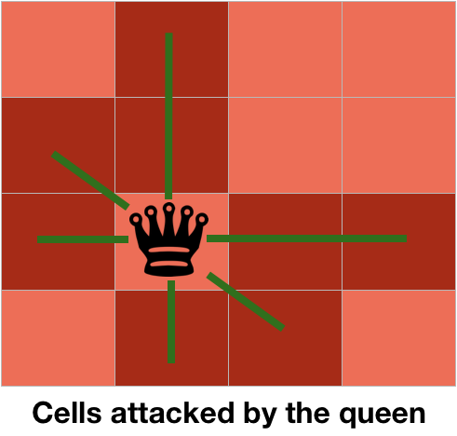

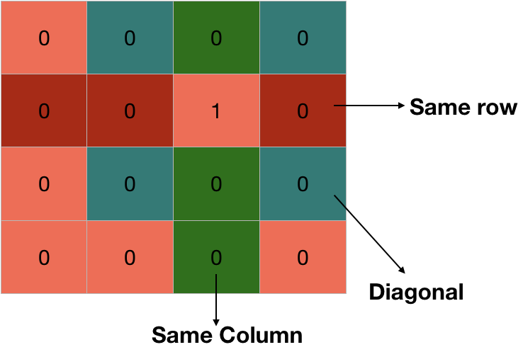

**State Space for 4 Queens problem**

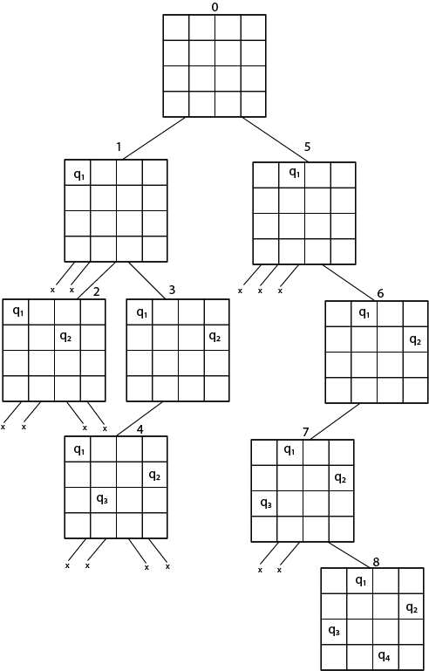

**Solution :**

1. Q1-2,Q2- 4,Q3- 1,Q4- 3
2. Q1-3,Q2-1,Q3-4,Q4-2

**Algorithm:**

IS-ATTACK(i, j, board, N)

// checking in the column j

for k in 1 to i-1

if board[k][j]==1

return TRUE

// checking upper right diagonal

k = i-1

l = j+1

while k>=1 and l<=N

if board[k][l] == 1

return TRUE

k=k+1

l=l+1

// checking upper left diagonal

k = i-1

l = j-1

while k>=1 and l>=1

if board[k][l] == 1

return TRUE

k=k-1

l=l-1

return FALSE

N-QUEEN(row, n, N, board)

if n==0

return TRUE

for j in 1 to N

if !IS-ATTACK(row, j, board, N)

board[row][j] = 1

if N-QUEEN(row+1, n-1, N, board)

return TRUE

board[row][j] = 0 //backtracking, changing current decision return FALSE

|  |  |  |  |
| --- | --- | --- | --- |
|  |  |  |  |
|  | (i--,j--)(Upper left Diagonal) |  |  |
|  |  | (i,j)  (Queen Position) |  |
|  | (i++,j--)(Bottom right diagonal) |  |  |

**Time Complexity Analysis**

1. the isPossible method takes O(n) time

2. for each invocation of loop in nQueenHelper, it runs for O(n) time

3. the isPossible condition is present in the loop and also calls nQueenHelper which is recursive adding this up, the recurrence relation is:

T(n) = O(n2) + n * T(n-1) solving the above recurrence by iteration or recursion tree, the time complexity of the nQueen problem is = O(N!)

**CONCLUSION:** Hence , We have Successfully implemented n queens problem using Backtracking and Branch and Bound Method

**Assignment No. 6**

**TITLE:** Write a program for analysis of quick sort by using deterministic and randomized variants.

**OBJECTIVE:** Analyze performance of an algorithm.

**OUTCOME:** Analyze performance of an algorithm.

**THEORY:**

**Quicksort:**

There are two variants of quicksort:

· Deterministic

· Randomized

Deterministic means that the quicksort will always sort the same set of data in the same fashion while a randomized quicksort uses randomization and will rarely sort the same data in the same exact fashion (unless the data set is very small - then it is more common).

**Deterministic**

It comes down to how the pivots are chosen. In a deterministic quicksort, the pivots are chosen by either always choosing the pivot at the same relative index such as the first, last, or middle element or by using the median of any number of predetermined element choices. For instance, a common method is to choose the median of first, last, and middle elements as the pivot. Even with the median-of-3 method I just described, certain datasets can easily give O(N^2) time complexity. An example dataset is the so-called organ pipes set of data:

array = [1,2,3,4,5,6,7,8,9,10,9,8,7,6,5,4,3,2,1]

**Randomized**

Randomizated quicksorts can choose just a random pivot or use the median of some number of randomly chosen pivots. There is still the possibility of O(N^2) time complexity, but the probability is much, much smaller and becomes smaller with increasing dataset size.

**QuickSort using Random Pivoting**

In this article, we will discuss how to implement [QuickSort](https://www.geeksforgeeks.org/quick-sort/) using random pivoting. In QuickSort we first partition the array in place such that all elements to the left of the pivot element are smaller, while all elements to the right of the pivot are greater than the pivot. Then we recursively call the same procedure for left and right subarrays.

Unlike [merge sort](https://www.geeksforgeeks.org/merge-sort/), we don’t need to merge the two sorted arrays. Thus Quicksort requires lesser auxiliary space than Merge Sort, which is why it is often preferred to Merge Sort. Using a randomly generated pivot we can further improve the time complexity of QuickSort.

We have discussed at two popular methods for partitioning the arrays-[Hoare’s vs Lomuto partition scheme](https://www.geeksforgeeks.org/hoares-vs-lomuto-partition-scheme-quicksort/)

It is advised that the reader has read that article or knows how to implement the QuickSort using either of the two partition schemes.

**Lomuto’s Partition Scheme:**

This algorithm works by assuming the pivot element as the last element. If any other element is given as a pivot element then swap it first with the last element. Now initialize two variables i as low and j also low, iterate over the array and increment i when arr[j] <= pivot and swap arr[i] with arr[j] otherwise increment only j. After coming out from the loop swap arr[i] with arr[hi]. This i stores the pivot element.

**Algorithm for random pivoting using Lomuto Partitioning**

partition(arr[], lo, hi)

pivot = arr[hi]

i = lo // place for swapping

for j := lo to hi – 1 do

if arr[j] <= pivot then

swap arr[i] with arr[j]

i = i + 1

swap arr[i] with arr[hi]

return i

partition_r(arr[], lo, hi)

r = Random Number from lo to hi

Swap arr[r] and arr[hi]

return partition(arr, lo, hi)

quicksort(arr[], lo, hi)

if lo < hi

p = partition_r(arr, lo, hi)

quicksort(arr, lo , p-1)

quicksort(arr, p+1, hi)

**Hoare’s Partition Scheme:**

[Hoare’s Partition Scheme](https://en.wikipedia.org/wiki/Quicksort#Hoare_partition_scheme) works by initializing two indexes that start at two ends, the two indexes move toward each other until an inversion is (A smaller value on the left side and greater value on the right side) found. When an inversion is found, two values are swapped and the process is repeated.

partition(arr[], lo, hi)

pivot = arr[lo]

i = lo - 1 // Initialize left index

j = hi + 1 // Initialize right index

// Find a value in left side greater

// than pivot

do

i = i + 1

while arr[i] < pivot

// Find a value in right side smaller

// than pivot

do

j--;

while (arr[j] > pivot);

if i >= j then

return j

swap arr[i] with arr[j]

**Assignment No. 7A**

**TITLE:** Write a program to implement matrix multiplication. Also implement multithreaded matrix multiplication with either one thread per row or one thread per cell. Analyze and compare their performance

**OBJECTIVE:** Analyze performance of an algorithm.

**OUTCOME:** Analyze performance of an algorithm.

**THEORY:**

In mathematics, particularly in linear algebra, matrix multiplication is a binary operation that produces a matrix from two matrices. For matrix multiplication, the number of columns in the first matrix must be equal to the number of rows in the second matrix. The resulting matrix, known as the matrix product, has the number of rows of the first and the number of columns of the second matrix. The product of matrices A and B is denoted as AB.

Matrix multiplication was first described by the French mathematician Jacques Philippe Marie Binet in 1812,[2] to represent the composition of linear maps that are represented by matrices. Matrix multiplication is thus a basic tool of linear algebra, and as such has numerous applications in many areas of mathematics, as well as in applied mathematics, statistics, physics, economics, and engineering.[3][4] Computing matrix products is a central operation in all computational applications of linear algebra.

**Pseudo code for matrix multiplication:**

matrixMultiply(A, B):

Assume dimension of A is (m x n), dimension of B is (p x q)

Begin

if n is not same as p, then exit

otherwise define C matrix as (m x q)

for i in range 0 to m - 1, do

for j in range 0 to q – 1, do

for k in range 0 to p, do

C[i, j] = C[i, j] + (A[i, k] * A[k, j])

done

done

done

End

**Multiplication of Matrix using threads**

**Multiplication of matrix** does take time surely. Time complexity of matrix multiplication is O(n^3) using normal matrix multiplication. And **Strassen algorithm** improves it and its time complexity is O(n^(2.8074)).

But, Is there any way to improve the performance of matrix multiplication using the normal method.

**Multi-threading** can be done to improve it. In multi-threading, instead of utilizing a single core of your processor, we utilizes all or more core to solve the problem.

We create different threads, each thread evaluating some part of matrix multiplication.

Depending upon the number of cores your processor has, you can create the number of threads required. Although you can create as many threads as you need, a better way is to create each thread for one core.

In second approach,we create a separate thread for each element in resultant matrix. Using **pthread_exit()** we return computed value from each thread which is collected by **pthread_join()**. This approach does not make use of any global variables.

Input :

Matrix A

1 0 0

0 1 0

0 0 1

Matrix B

2 3 2

4 5 1

7 8 6

Output : Multiplication of A and B

2 3 2

4 5 1

7 8 6

// CPP Program to multiply two matrix using pthreads

#include <bits/stdc++.h>

using namespace std;

// maximum size of matrix

#define MAX 4

// maximum number of threads

#define MAX_THREAD 4

int matA[MAX][MAX];

int matB[MAX][MAX];

int matC[MAX][MAX];

int step_i = 0;

void* multi(void* arg)

{

int i = step_i++; //i denotes row number of resultant matC

for (int j = 0; j < MAX; j++)

for (int k = 0; k < MAX; k++)

matC[i][j] += matA[i][k] * matB[k][j];

}

// Driver Code

int main()

{

// Generating random values in matA and matB

for (int i = 0; i < MAX; i++) {

for (int j = 0; j < MAX; j++) {

matA[i][j] = rand() % 10;

matB[i][j] = rand() % 10;

}

}

// Displaying matA

cout << endl

<< "Matrix A" << endl;

for (int i = 0; i < MAX; i++) {

for (int j = 0; j < MAX; j++)

cout << matA[i][j] << " ";

cout << endl;

}

// Displaying matB

cout << endl

<< "Matrix B" << endl;

for (int i = 0; i < MAX; i++) {

for (int j = 0; j < MAX; j++)

cout << matB[i][j] << " ";

cout << endl;

}

// declaring four threads

pthread_t threads[MAX_THREAD];

// Creating four threads, each evaluating its own part

for (int i = 0; i < MAX_THREAD; i++) {

int* p;

pthread_create(&threads[i], NULL, multi, (void*)(p));

}

// joining and waiting for all threads to complete

for (int i = 0; i < MAX_THREAD; i++)

pthread_join(threads[i], NULL);

// Displaying the result matrix

cout << endl

<< "Multiplication of A and B" << endl;

for (int i = 0; i < MAX; i++) {

for (int j = 0; j < MAX; j++)

cout << matC[i][j] << " ";

cout << endl;

}

return 0;

}

**Output:**

Matrix A

3 7 3 6

9 2 0 3

0 2 1 7

2 2 7 9

Matrix B

6 5 5 2

1 7 9 6

6 6 8 9

0 3 5 2

Multiplication of A and B

43 100 132 87

56 68 78 36

8 41 61 35

56 93 129 97

**Conclusion:**

Hence , We have successfully implemented matrix multiplication using multithreading.

FAQ’s

1. Analyze the performance of multithreaded matrix multiplication
2. Explain Naive string matching algorithm
3. Explain airline Crew Scheduling problem

**Assignment No. 5B**

**TITLE:** Implement merge sort and multithreaded merge sort. Compare time required by both the algorithms. Also analyze the performance of each algorithm for the best case and the worst case

**OBJECTIVE:** Analyze performance of an algorithm.

**OUTCOME:** Analyze performance of an algorithm.

**THEORY:**

Merge sort is based on divide-and-conquer technique. Merge sort method is a two phase

process-

1. Dividing

2. Merging

Dividing Phase: During the dividing phase, each time the given list of elements is divided into

two parts. This division process continues until the list is small enough to divide.

Merging Phase: Merging is the process of combining two sorted lists, so that, the resultant list is

also the sorted one. Suppose A is a sorted list with n element and B is a sorted list with n 2

elements. The operation that combines the elements of A and B into a single sorted list C with

n=n 1 + n 2, elements is called merging.

Algorithm-(Divide algorithm)

Algorithm Divide (a, low, high)

{

// a is an array, low is the starting index and high is the end index of a

If( low < high) then

{

Mid: = (low + high) /2;

Divide( a, low, mid);

Divide( a, mid +1, high);

Merge(a, low, mid, high);

}

}

The merging algorithm is as follows-

Algorithm Merge( a, low, mid, high)

{

L:= low;

H:= high;

J:= mid +1;

K:= low;

While (low mid AND j high) do

{

If (a[low < a[j]) then

{

B[k] = a[low];

K:= k+1;

Low:= low+1;

}

Else

{

B[k]= a[j];

K: = k+1;

J: = j+1;

}

}

While (low<= mid) do

{

B[k]=a[low];

K: = k+1;

Low: =low + 1;

}

While (j<= high) do

{

B[k]=a[j];

K: = k+1;

j: =j + 1;

}

//copy elements of b to a

For i: = l to n do

{

A[i]: =b[i];

}

}

Example:

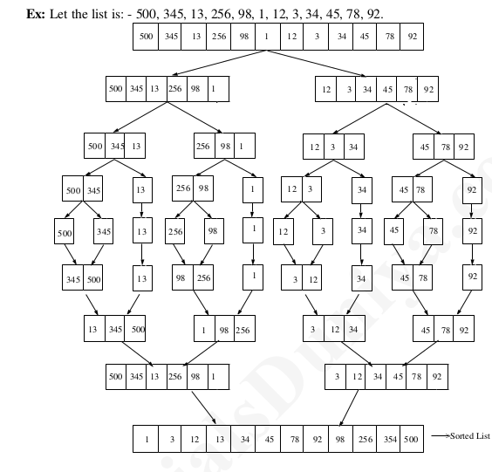

**The merge sort algorithm works as follows-**

Step 1: If the length of the list is 0 or 1, then it is already sorted, otherwise,

Step 2: Divide the unsorted list into two sub-lists of about half the size.

Step 3: Again sub-divide the sub-list into two parts. This process continues until each element in

the list becomes a single element.

Step 4: Apply merging to each sub-list and continue this process until we get one sorted list.

**Efficiency of Merge List:**

Let ‘n’ be the size of the given list/ then the running time for merge

sort is given by the recurrence relation.

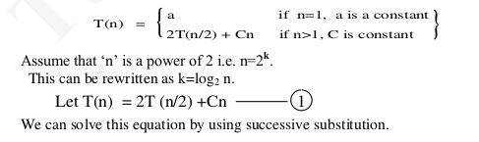

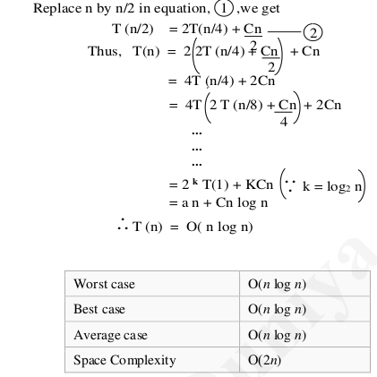

**CONCLUSION: Hence , We have Successfully implemented merge sort using multithreading.**

**FAQ’s:**

1. Write control abstraction for Divide and Conquer strategy
2. What are the basic asymptotic efficiency classes?
3. Compare the order of growth n(n-1)/2 and n^2.

**Assignment No. 5C**

**TITLE:** Implement the Naive string matching algorithm and Rabin-Karp algorithm for string matching. Observe difference in working of both the algorithms for the same input.

**OBJECTIVE:** Analyze performance of an algorithm.

**OUTCOME:** Analyze performance of an algorithm.

**THEORY:**

String Matching Algorithm is also called "String Searching Algorithm." This is a vital class of string algorithm that is declared as "this is the method to find a place where one of several strings are found within the larger string."

Given a text array, T [1.....n], of n character and a pattern array, P [1......m], of m characters. The problems are to find an integer s, called a valid shift where 0 ≤ s < n-m and T [s+1......s+m] = P [1......m]. In other words, to find even if P in T, i.e., where P is a substring of T. The item of P and T are characters drawn from some finite alphabet such as {0, 1} or {A, B .....Z, a, b..... z}.

Given a string T [1......n], the substrings are represented as T [i......j] for some 0≤i ≤ j≤n-1, the string formed by the characters in T from index i to index j, inclusive. This process that a string is a substring of itself (take i = 0 and j =m).

The proper substring of string T [1......n] is T [1......j] for some 0<i ≤ j≤n-1. That is, we must have either i>0 or j < m-1.

Using these descriptions, we can say given any string T [1......n], the substrings are

T [i.....j] = T [i] T [i +1] T [i+2]......T [j] for some 0≤i ≤ j≤n-1.

And proper substrings are

T [i.....j] = T [i] T [i +1] T [i+2]......T [j] for some 0≤i ≤ j≤n-1.

Note: If i>j, then T [i.....j] is equal to the empty string or null, which has length zero.

**Following are the string matching algorithms:**

**1.** The Naive String Matching Algorithm

2. The Rabin-Karp-Algorithm

3. Finite Automata

4. The Knuth-Morris-Pratt Algorithm

5. The Boyer-Moore Algorithm

**1. Naïve string matching algorithm:**

The naïve approach tests all the possible placement of Pattern P [1.......m] relative to text T [1......n]. We try shift s = 0, 1.......n-m, successively and for each shift s. Compare T [s+1.......s+m] to P [1......m].

The naïve algorithm finds all valid shifts using a loop that checks the condition P [1.......m] = T [s+1.......s+m] for each of the n - m +1 possible value of s.

* **Pseudocode for Naïve string-matching algorithm:**

**NAIVE-STRING-MATCHER (T, P)**

1. n ← length [T]

2. m ← length [P]

3. for s ← 0 to n -m

4. do if P [1.....m] = T [s + 1....s + m]

5. then print "Pattern occurs with shift" s

* **Analysis:**

This for loop from 3 to 5 executes for n-m + 1(we need at least m characters at the end) times and in iteration we are doing m comparisons. So the total complexity is O (n-m+1).

* Suppose T = 1011101110
* P = 111
* Find all the Valid Shift

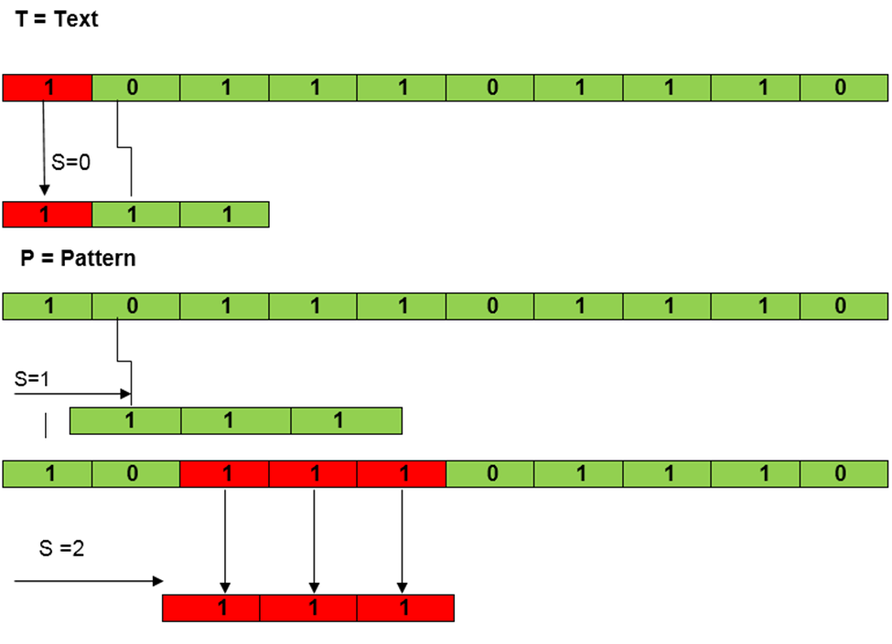

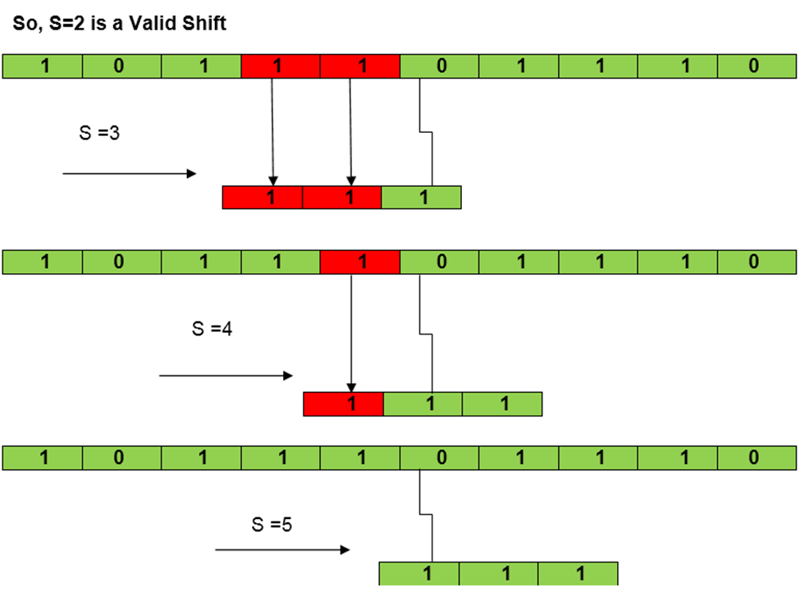

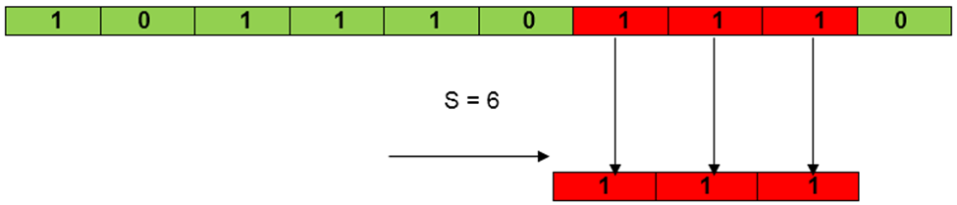

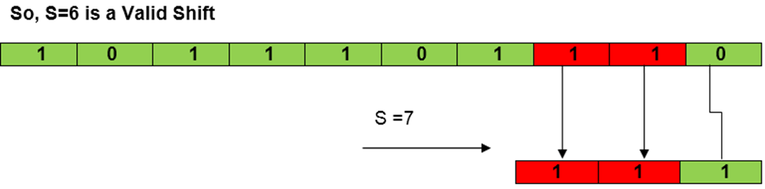

**2. Rabin-Karp-Algorithm:**

The Rabin-Karp string matching algorithm calculates a hash value for the pattern, as well as for each M-character subsequences of text to be compared. If the hash values are unequal, the algorithm will determine the hash value for the next M-character sequence. If the hash values are equal, the algorithm will analyze the pattern and the M-character sequence. In this way, there is only one comparison per text subsequence, and character matching is only required when the hash values match.

**• Pseudocode for Rabin-Karp algorithm:**

**RABIN-KARP-MATCHER (T, P, d, q)**

1. n ← length [T]

2. m ← length [P]

3. h ← dm-1 mod q

4. p ← 0

5. t0 ← 0

6. for i ← 1 to m

7. do p ← (dp + P[i]) mod q

8. t0 ← (dt0+T [i]) mod q

9. for s ← 0 to n-m

10. do if p = ts

11. then if P [1.....m] = T [s+1.....s + m]

12. then "Pattern occurs with shift" s

13. If s < n-m

14. then ts+1 ← (d (ts-T [s+1]h)+T [s+m+1])mod q

**• Example:**

For string matching, working module q = 11, how many spurious hits does the Rabin-Karp matcher encounter in Text T = 31415926535.......

1. T = 31415926535.......

2. P = 26

3. Here T.Length =11 so Q = 11

4. And P mod Q = 26 mod 11 = 4

5. Now find the exact match of P mod Q...

**Solution:**

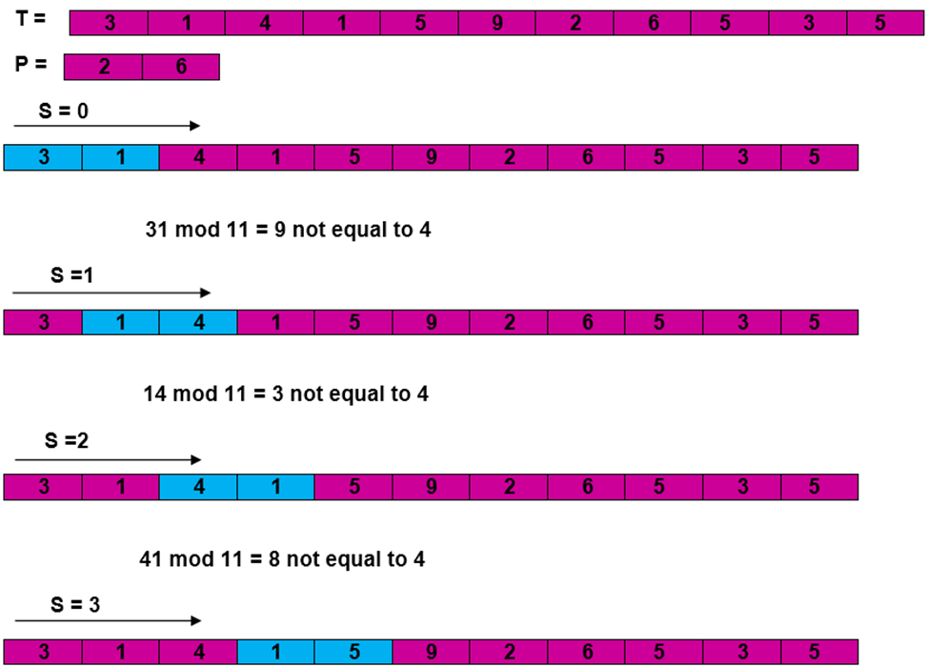

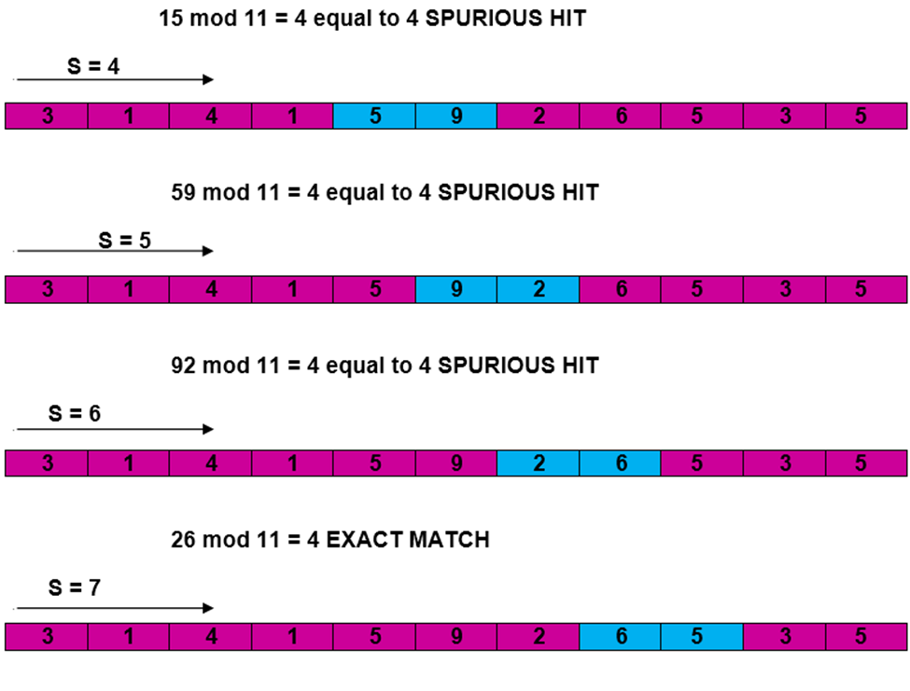

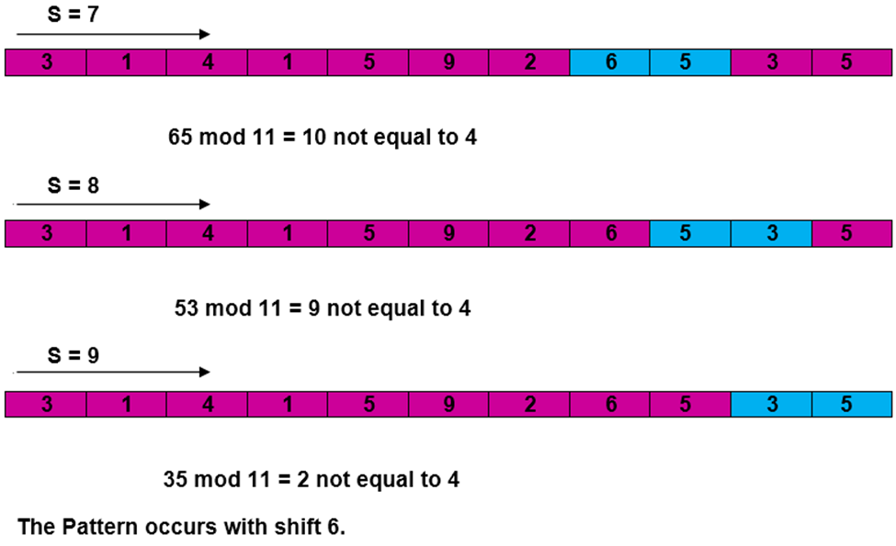

**Complexity:**

The running time of RABIN-KARP-MATCHER in the worst-case scenario O ((n-m+1) m but it has a good average case running time. If the expected number of strong shifts is small O (1) and prime q is chosen to be quite large, then the Rabin-Karp algorithm can be expected to run in time O (n+m) plus the time required to process spurious hits.

**Conclusion:Hence , We have successfully implemented Robin Karp algorithm**

**FAQ:**

1.What are the applications of the Robin Karp algorithm?

2.What is the difference between breadth first search and distributed breadth first search?

3.Explain the distributed minimum spanning tree .

**Content Beyond Syllabus**

**TITLE:**

**OBJECTIVE:**

**OUTCOME:**

**N Queen Problem using Branch And Bound**

The N queens puzzle is the problem of placing N chess queens on an N×N chessboard so that no two queens threaten each other. Thus, a solution requires that no two queens share the same row, column, or diagonal.

In backtracking solution we backtrack when we hit a dead end. In Branch and Bound solution, after building a partial solution, we figure out that there is no point going any deeper as we are going to hit a dead end.

Let’s begin by describing backtracking solution. “The idea is to place queens one by one in different columns, starting from the leftmost column. When we place a queen in a column, we check for clashes with already placed queens. In the current column, if we find a row for which there is no clash, we mark this row and column as part of the solution. If we do not find such a row due to clashes, then we backtrack and return false.”

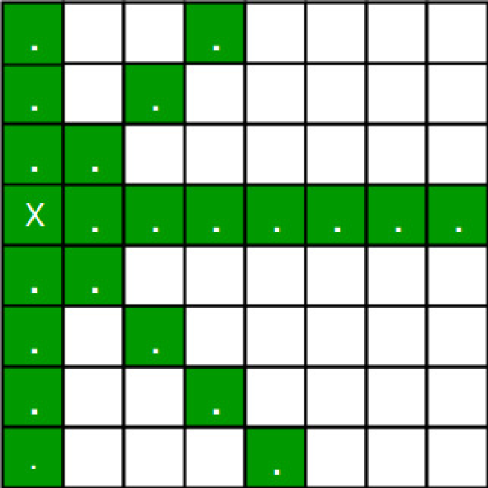

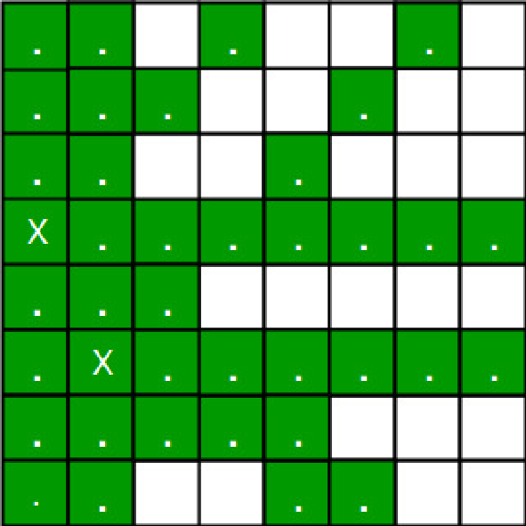

* For the 1st Queen, there are total 8 possibilities as we can place 1st Queen in any row of the first column. Let’s place Queen 1 on row 3.
* After placing 1st Queen, there are 7 possibilities left for the 2nd Queen. But wait, we don’t really have 7 possibilities. We cannot place Queen 2 on rows 2, 3 or 4 as those cells are under attack from Queen 1. So, Queen 2 has only 8 – 3 = 5 valid positions left.
* After picking a position for Queen 2, Queen 3 has even fewer options as Most of the cells in its column are under attack from the first 2 Queens.

We need to figure out an efficient way of keeping track of which cells are under attack.

Basically, we have to ensure 4 things:

1. No two queens share a column.

2. No two queens share a row.

3. No two queens share a top-right to left-bottom diagonal.

4. No two queens share a top-left to bottom-right diagonal.

Number 1 is automatic because of the way we store the solution.

For number 2, 3 and 4, we can perform updates in O(1) time.

The idea is to keep three Boolean arrays that tell us which rows and which diagonals are occupied.

Lets do some pre-processing first. Let’s create two N x N matrix one for / diagonal and other one for \ diagonal. Let’s call them slashCode and backslashCode respectively.

The trick is to fill them in such a way that two queens sharing a same / diagonal will have the same value in matrix slashCode, and if they share same \ diagonal, they will have the same value in backslashCode matrix.

For an N x N matrix, fill slashCode and backslashCode matrix using below formula –

slashCode[row][col] = row + col

backslashCode[row][col] = row – col + (N-1)

Using above formula will result in below matrices

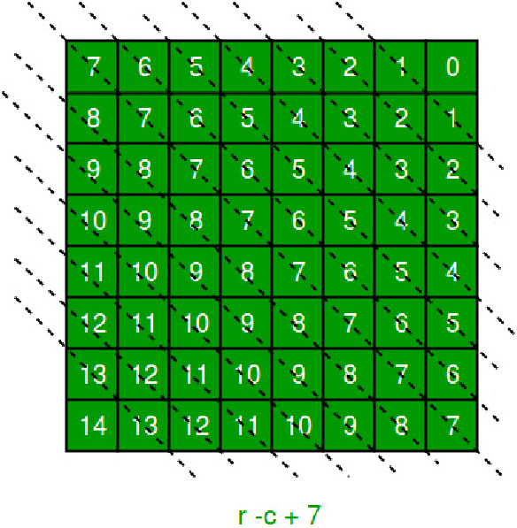

//backslashCode

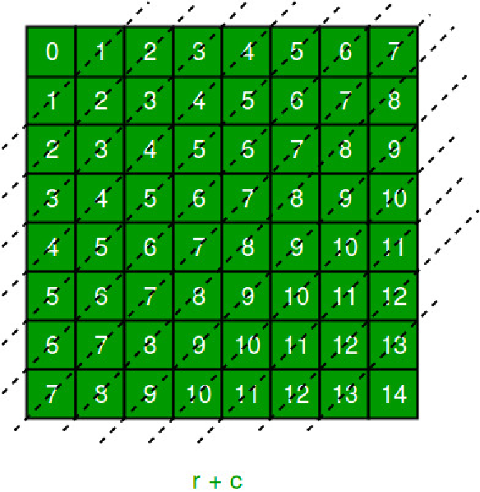

//Slashcode

The ‘N – 1’ in the backslash code is there to ensure that the codes are never negative because we will be using the codes as indices in an array.

For placing a queen i on row j, check the following :

* whether row 'j' is used or not
* whether slashDiagnol 'i+j' is used or not
* whether backSlashDiagnol 'i-j+7' is used or not

If the answer to any one of the following is true, we try another location for queen i on row j, mark the row and diagonals; and recur for queen i+1.

**Explanation**

consider the example of a 4x4 chessboard

initially, board matrix:

0 0 0 0

0 0 0 0

0 0 0 0

0 0 0 0

rowLook array:

[ false, false, false, false]

slashDiagnolLook array (size = 2xn-1 = 7):

[ false, false, false, false, false, false, false]

backSlashDiagnolLook array (size = 2xn-1 = 7):

[ false, false, false, false, false, false, false]

preprocessed matrices are as follows:

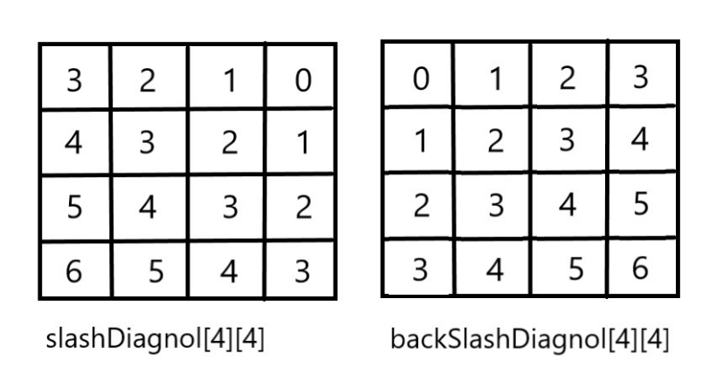

**Conclusion:**

Hence, We have successfully implemented 8 queens using branch and bound strategy

**FAQs:**

1.Write Control abstraction for branch and bound method?

2.Discuss FIFO branch and bound strategy with example?

1. Discuss LC branch and bound strategy with example?